Master Functional Document

Application | NGERP - Centra
Service Bundle | Master Management
Service Request | Transaction Group Config

Description :

Transaction Group Config Masters is used to give window access and group acces to the user. If a transaction group is not active the system will not show the window or partner group.

Workflow Process :

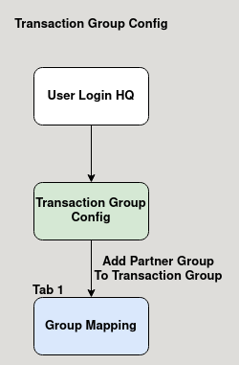

Business Rules :

- User showld login HQ to edit transaction group config.
- User can activate or deactive a window in the master.
- User add a partner group in the group mapping tab in the transaction group config master.
- User can also activate or deactivate the user group in the group mapping tab.

